Experiment No. 3
Energy and Power Analysis of Signals
OBJECTIVE:
To calculate the energy and average power of given continuous-time and discrete-time signals and classify them as energy signals, power signals, or neither based on their energy and power characteristics.
Experimental Procedure:
- Define the time vector and generate the selected signals.
- Compute the squared magnitude of each signal.
- Numerically integrate over a sufficiently large interval for energy.
- Compute average power over an interval containing several periods for the periodic signal.
- Compare numerical results with analytical expectations.
- Classify the signals and record observations.

MATLAB Coding:

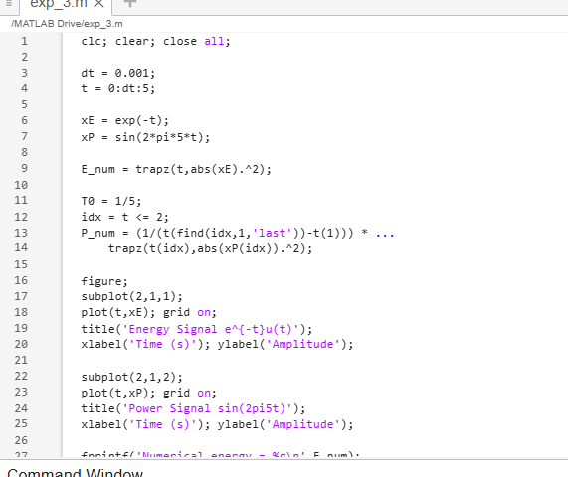

Results:
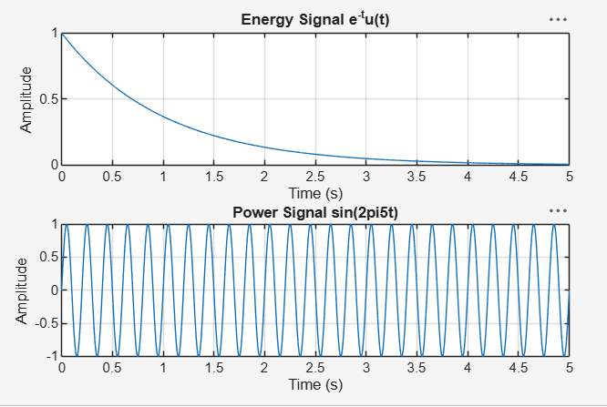

Conclusion:
Energy and average power were calculated successfully, and the given signals were classified as energy and power signals based on their energy and power characteristics.

